**ENVIRONMENT CELL**

**ANNUAL REPORT**

**2024-2025**

**Tree Plantation Drive**

Date: August 13, 2024

Theme: “Ek Ped Maa ke Naam”

**Objective:** To enhance green cover and promote environmental consciousness through tree plantation.

On August 13, 2024, a tree plantation drive was organized by the Environment Awareness Cell of St. Bede’s College Shimla. The main objective of this event was to enhance green cover and promote environmental consciousness. The initiative, organized by Environment Awareness Cell, focused on planting Deodar and Horse Chestnut trees. The event witnessed an active participation of enthusiastic students of St. Bede’s College. Volunteers were briefed on planting techniques and environmental benefits. The saplings were planted in designated areas, ensuring proper spacing and depth. This event not only added 30 saplings to the college campus but also raised awareness about the importance of trees and environmental stewardship among the students.

**Outcome:** 30 saplings of Deodar and Horse Chestnut were planted, fostering environmental awareness among students.

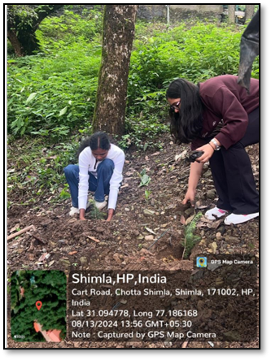 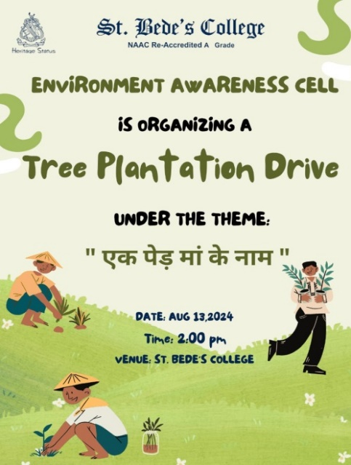

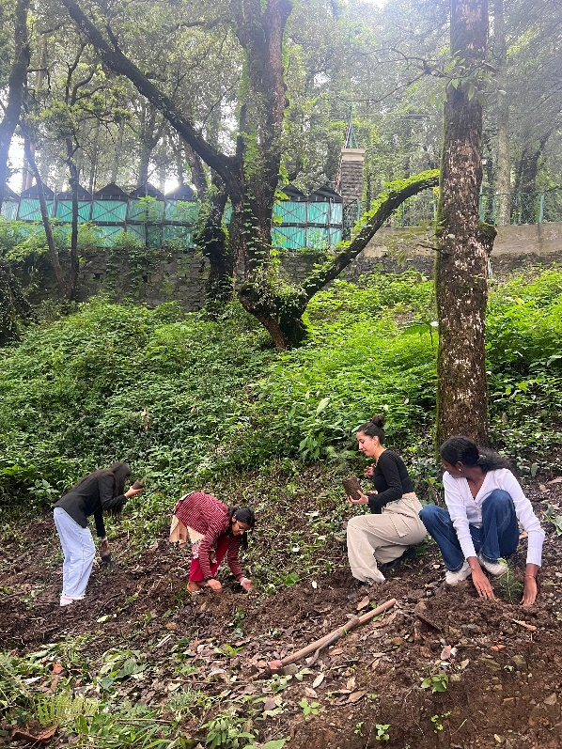 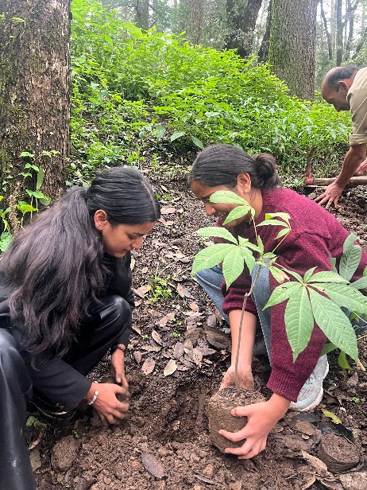

**Tree Plantation Drive organized on August 13, 2024**

**Poster Making Competition**

Date: September 29, 2024

Theme: Waterways of life

**Objective:** To raise awareness about the importance of conserving waterways through creative expression.

On September 29, 2024, the Environment Awareness Cell organised a Poster Making Competition on ‘World Rivers Day’ on the theme ‘Waterways of Life’. The competition attracted a diverse group of participants from different courses and each brought a unique perspective on how to conserve our waterways.

The panel of judges assessed the posters based on creativity, message clarity, artistic quality, and relevance to the theme.

The competition was concluded with the names of the winners:

1st Position: Nupur Thakur (B.sc Biotechnology Hons 1st year)

2nd Position: Rozali Thapa (B.A. English Hons 3rd year)

**Outcome:** Engaged diverse participants, fostering unique perspectives on water conservation through poster art.

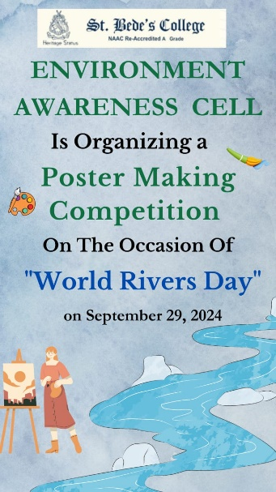

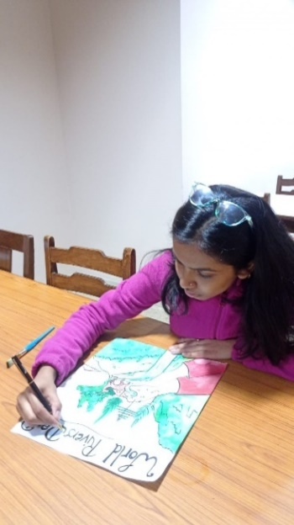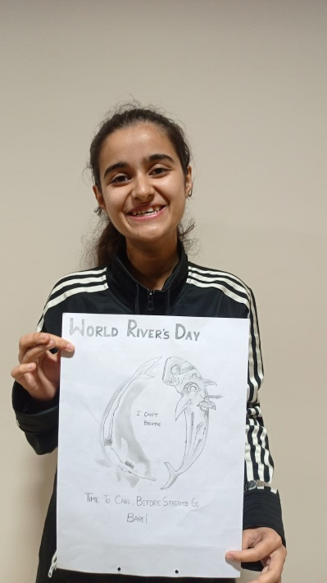

**Poster Making Competition organized on September 29, 2024**

Cleanliness Drive

Date: November 22, 2024

Theme: Clean and Green is the perfect dream

**Objective:** To promote hygiene, environmental sustainability, and community engagement through a cleanliness drive.

A cleanliness drive was organised on November 22, 2024 by the Environment Awareness Cell on the theme, ‘Clean and Green is the perfect dream.’ with the aim of promoting hygiene, environmental sustainability and community engagement. The event took place around the library and canteen area of the college, making people aware about their surroundings. The cleanliness drive was a successful step towards a cleaner and healthier environment. It demonstrated the power of collective effort in tackling environment issues.

**Outcome:** Successfully improved cleanliness around the library and canteen, highlighting the impact of collective efforts on environmental health.

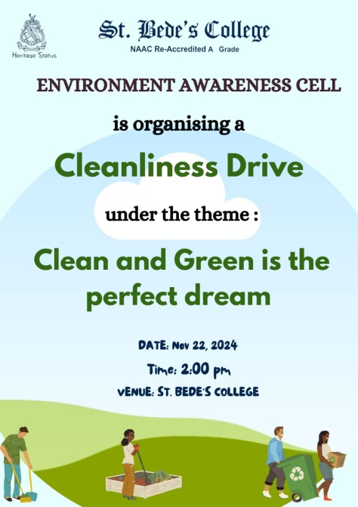 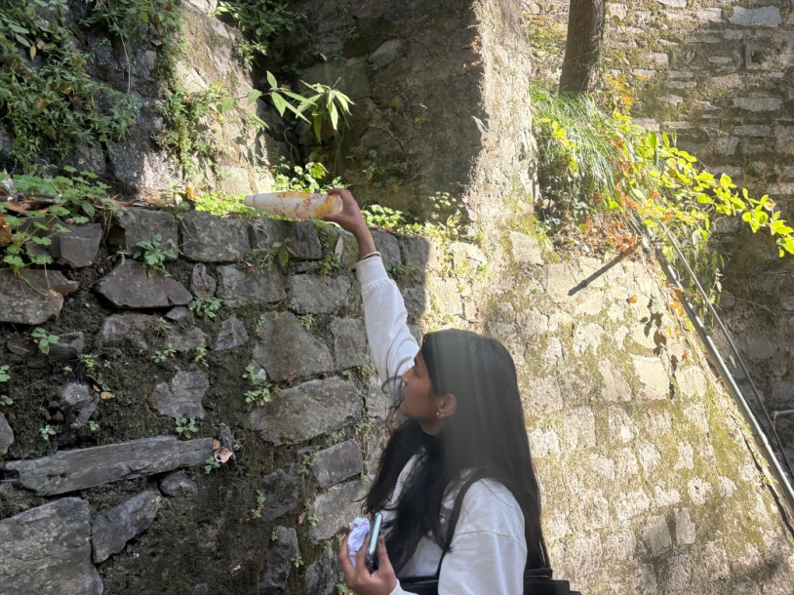

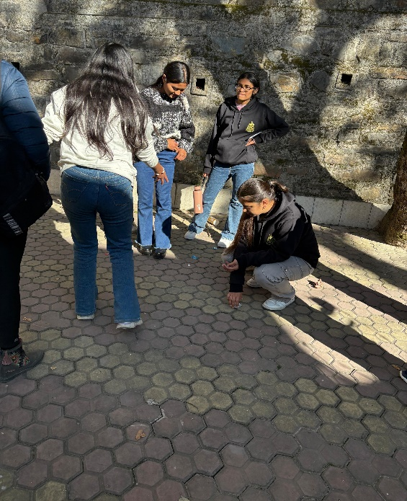 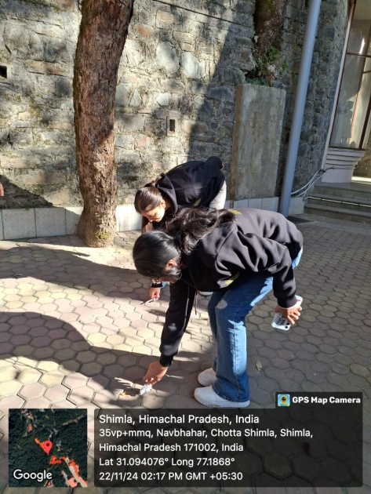

**Cleanliness Drive organized on November 22, 2024**

**Compost Sale**

Date: December 12, 2024

**Objective:** To promote sustainable waste management and support local agriculture through the sale of affordable, high-quality compost.

A compost sale was organised by Environment Awareness Cell in collaboration with the Department of Biotechnology and Microbiology on December 12, 2024 in the college., with the aim of providing affordable, high-quality compost for local farmers and gardeners improving plant growth and productivity in a sustainable manner. This event aimed at waste reduction, to raise awareness about the benefits of composting, waste management and sustainability, educating people on how they can reduce waste and contribute to greener practices.

**Outcome:** Raised awareness about composting and sustainability while providing eco-friendly compost to enhance plant growth and productivity.

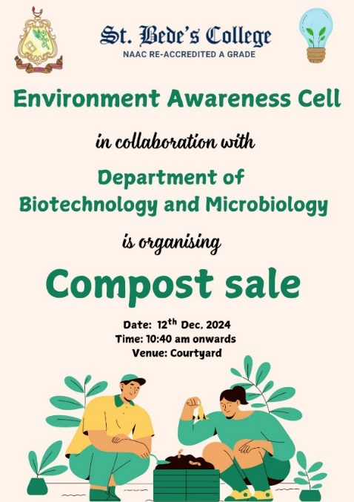

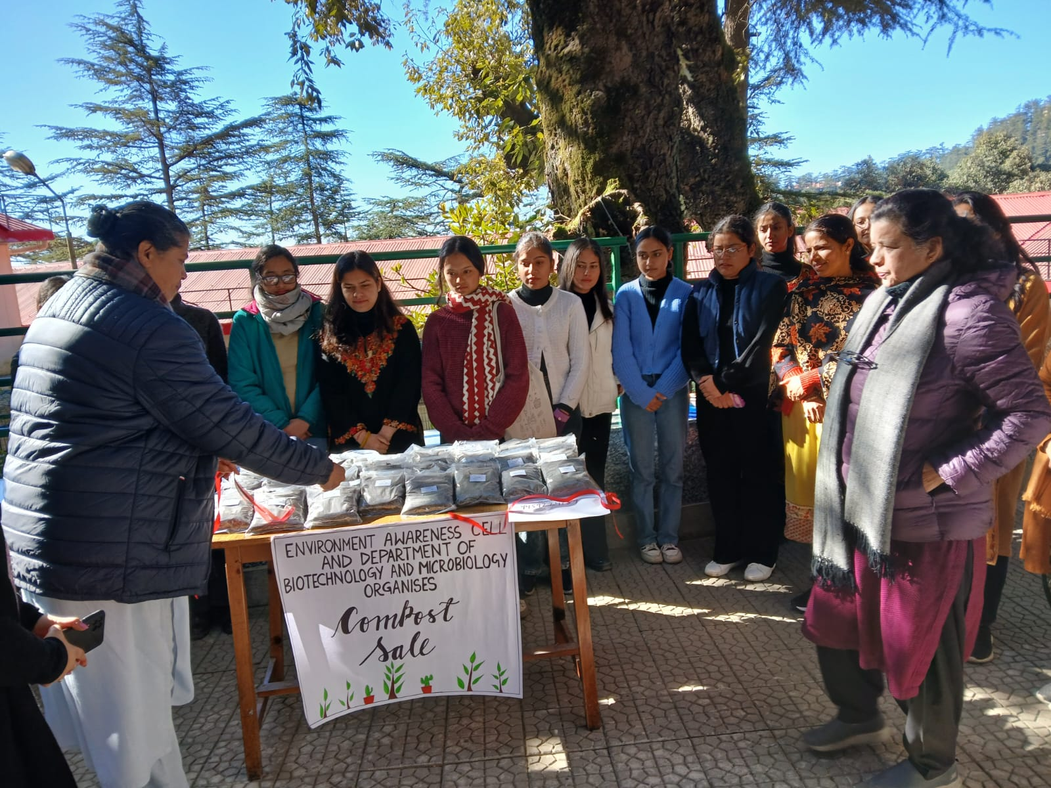

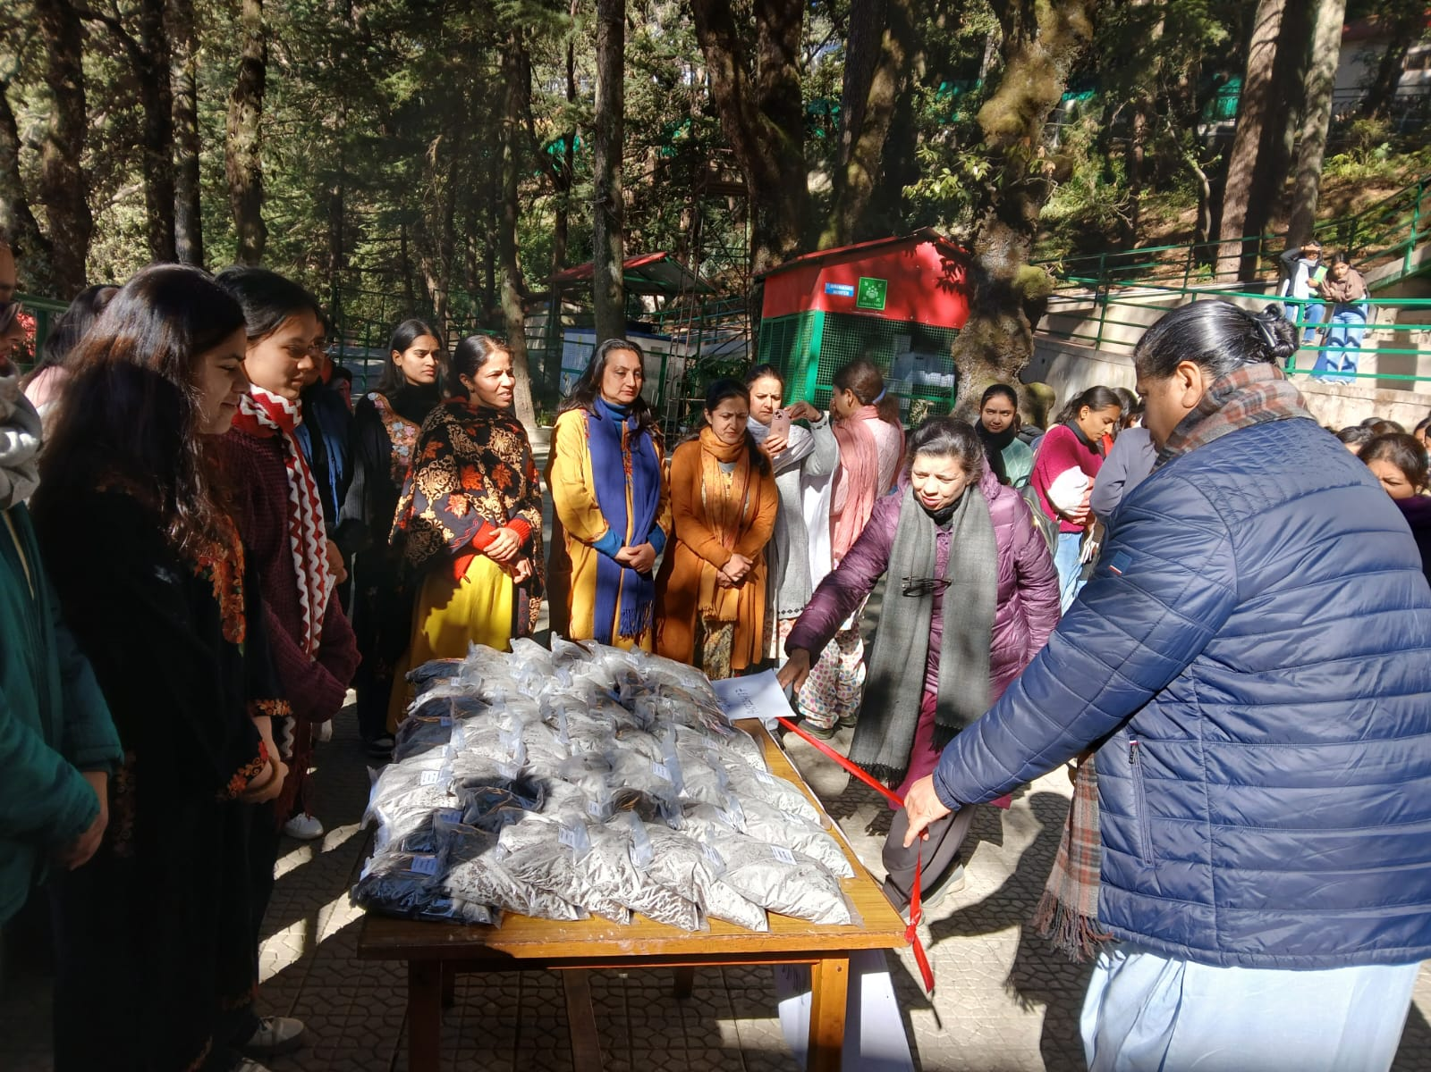

**Compost Sale organized on December 12, 2024**